程式：ReadTime(讀取RTC時間)
開啟程式ReadTime
程式位址：https://github.com/brucetsao/BruceCourses/blob/master/105ANQU_IOT/Code/ReadTime/ReadTime.ino
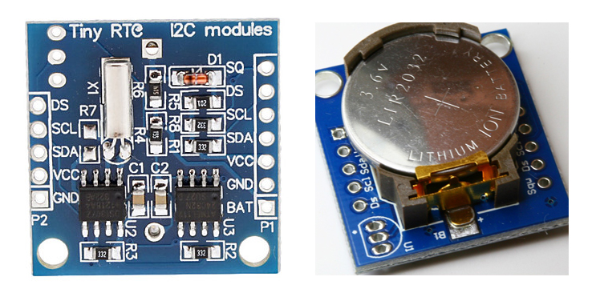
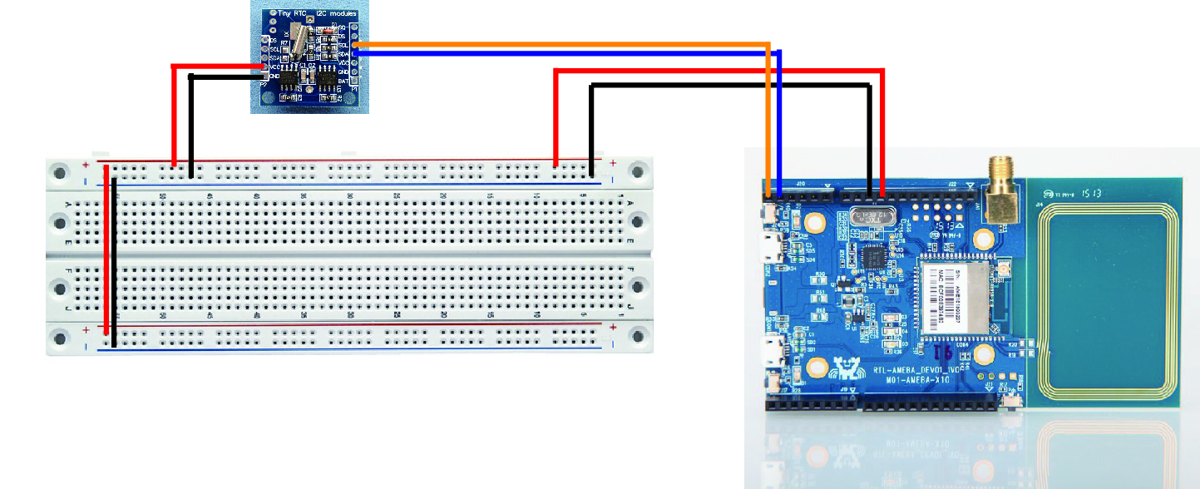

#include <Wire.h> // Arduino IDE 內建
// LCD I2C Library，從這裡可以下載：

#include "RTClib.h"
RTC_DS1307 RTC;

void setup() {
Serial.begin(9600);
initRTC() ;

}

void loop() {
Serial.print("Now Data and Time is :") ;
Serial.print(ShowDateTime()) ;
Serial.print("\n") ;
delay(1000) ;
}

void initRTC()
{
Wire.begin();
RTC.begin();
if (! RTC.isrunning()) {
Serial.println("RTC is NOT running!");
// following line sets the RTC to the date & time this sketch was compiled
// RTC.adjust(DateTime(__DATE__, __TIME__));

}
}
String ShowDateTime()
{

return StrDate() + " " +StrTime() ;
}

String StrDate() {
String ttt ;
//nowT = now;
DateTime now = RTC.now();
ttt = print4digits(now.year()) + "-" + print2digits(now.month()) + "-" + print2digits(now.day()) ;
//ttt = print4digits(NDPyear) + "/" + print2digits(NDPmonth) + "/" + print2digits(NDPday) ;
return ttt ;
}

String StringDate(int yyy,int mmm,int ddd) {
String ttt ;
//nowT = now;
ttt = print4digits(yyy) + "-" + print2digits(mmm) + "-" + print2digits(ddd) ;
return ttt ;
}

String StrTime() {
String ttt ;
// nowT = RTC.now();
DateTime now = RTC.now();
ttt = print2digits(now.hour()) + ":" + print2digits(now.minute()) + ":" + print2digits(now.second()) ;
// ttt = print2digits(NDPhour) + ":" + print2digits(NDPminute) + ":" + print2digits(NDPsecond) ;
return ttt ;
}

String StringTime(int hhh,int mmm,int sss) {
String ttt ;
ttt = print2digits(hhh) + ":" + print2digits(mmm) + ":" + print2digits(sss) ;
return ttt ;
}

String print2digits(int number) {
String ttt ;
if (number >= 0 && number < 10)
{
ttt = String("0") + String(number);
}
else
{
ttt = String(number);
}
return ttt ;
}

String print4digits(int number) {
String ttt ;
ttt = String(number);
return ttt ;
}

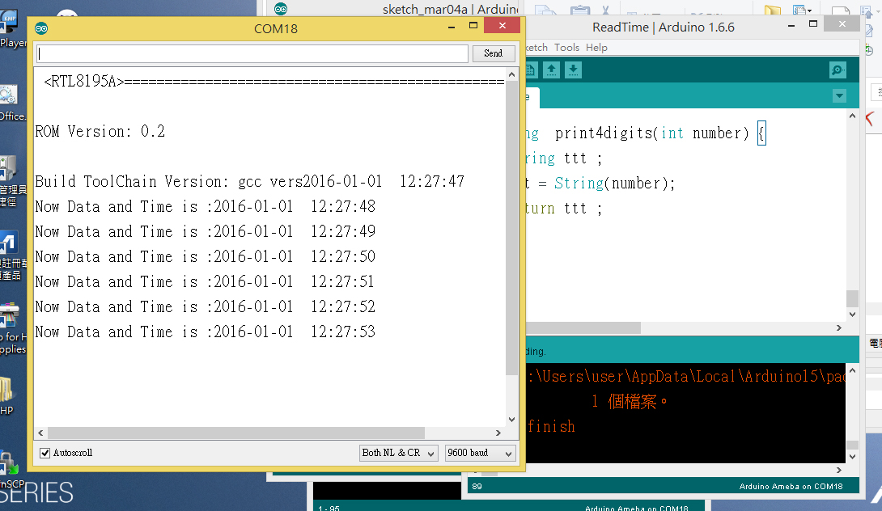

ReadTime程式重點解說
- #include <Wire.h> I2C通訊用
- #include “RTClib.h“ DS1307 時鐘模組用
- RTC_DS1307 RTC; 宣告時鐘物件
- initRTC() ; 啟動時鐘物件(自訂)
- Wire.begin(); 開始I2C通訊
- RTC.begin(); 開始時鐘物件通訊
- RTC.isrunning() 時鐘物件順利啟動
- ShowDateTime() 顯示DS1307 時鐘內容(自訂)

- DateTime now = RTC.now(); 取得RTC時鐘物件
- now.hour() 取得小時
- now.minute() 取得分
- now.second() 取得秒
- now.year() 取得年
- now.month() 取得月
- now.day() 取得日

