程式：lcd1602_I2C_mills 顯示資料在LCD上
開啟程式lcd1602_I2C_mills
程式位址：https://github.com/brucetsao/BruceCourses/blob/master/105ANQU_IOT/Code/lcd1602_I2C_mills/lcd1602_I2C_mills.ino

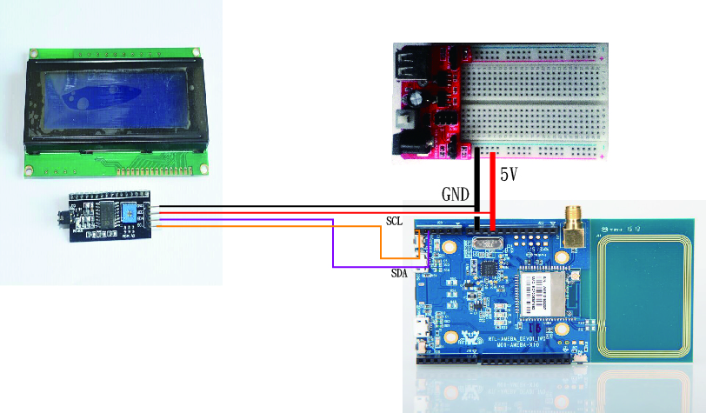

#include <I2CIO.h>
#include <LCD.h>
#include <LiquidCrystal_I2C.h>

/* YourDuino.com Example Software Sketch
16 character 2 line I2C Display
ANOTHER NEW TYPE Marked "LCM1602 IIC A0 A1 A2"
A0-A1-A2 are grounded so I2C Address is 0x20
terry@yourduino.com */
/*-----( Import needed libraries )-----*/
#include <Wire.h>
#include <LCD.h>
#include <LiquidCrystal_I2C.h> // F Malpartida's NewLiquidCrystal library
//Download: https://bitbucket.org/fmalpartida/new-liquidcrystal/downloads
// Move original LiquidCrystal library elsewhere, copy this in it's place

/*-----( Declare Constants )-----*/
#define I2C_ADDR 0x27 // Define I2C Address for the PCF8574T
//---(Following are the PCF8574 pin assignments to LCD connections )----
// This are different than earlier/different I2C LCD displays
#define BACKLIGHT_PIN 3
#define En_pin 2
#define Rw_pin 1
#define Rs_pin 0
#define D4_pin 4
#define D5_pin 5
#define D6_pin 6
#define D7_pin 7

#define LED_OFF 1
#define LED_ON 0

/*-----( Declare objects )-----*/
LiquidCrystal_I2C lcd(I2C_ADDR,En_pin,Rw_pin,Rs_pin,D4_pin,D5_pin,D6_pin,D7_pin);
// LiquidCrystal_I2C lcd(0x27, 2, 1, 0, 4, 5, 6, 7, 3, POSITIVE); // 設定 LCD I2C 位址
void setup() /*----( SETUP: RUNS ONCE )----*/
{
lcd.begin (16,2); // initialize the lcd
// Switch on the backlight
lcd.setBacklightPin(BACKLIGHT_PIN,POSITIVE);
lcd.setBacklight(LED_ON);
lcd.backlight(); //Backlight ON if under program control
lcd.setCursor(0,0); //Start at character 0 on line 0
lcd.print("Hello, world!");
}// END Setup

static int count=0;
void loop()
{
lcd.setCursor(0,1);
lcd.print("Realtek: ");
lcd.print(count++) ;
delay(1000);
} // END Loop

lcd1602_I2C_mills程式重點解說
- #include <I2CIO.h> I2C 函數
- #include <LCD.h> LCD函數
- #include <LiquidCrystal_I2C.h> I2C版LCD函數
- #define I2C_ADDR 0x27 設定LCD I2C位址
- lcd.begin (16,2); 設定LCD寬度與高度
- lcd.setBacklight(LED_ON); 設定LCD背光
- lcd.backlight();啟動LCD背光
- lcd.setCursor(0,0); LCD歸零定位
- lcd.print(“Hello, world!”); 印出Hello World

