程式：SetTime_fromNet 網路校時
開啟程式SetTime_fromNet
程式位址：https://github.com/brucetsao/BruceCourses/blob/master/105ANQU_IOT/Code/SetTime_fromNet/SetTime_fromNet.ino
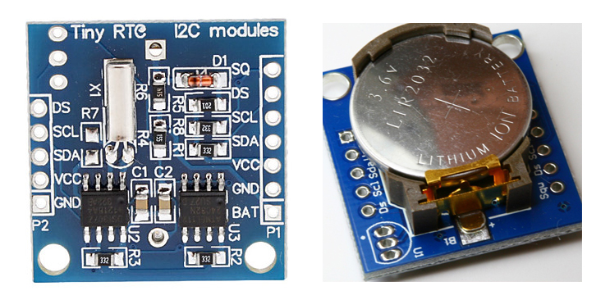
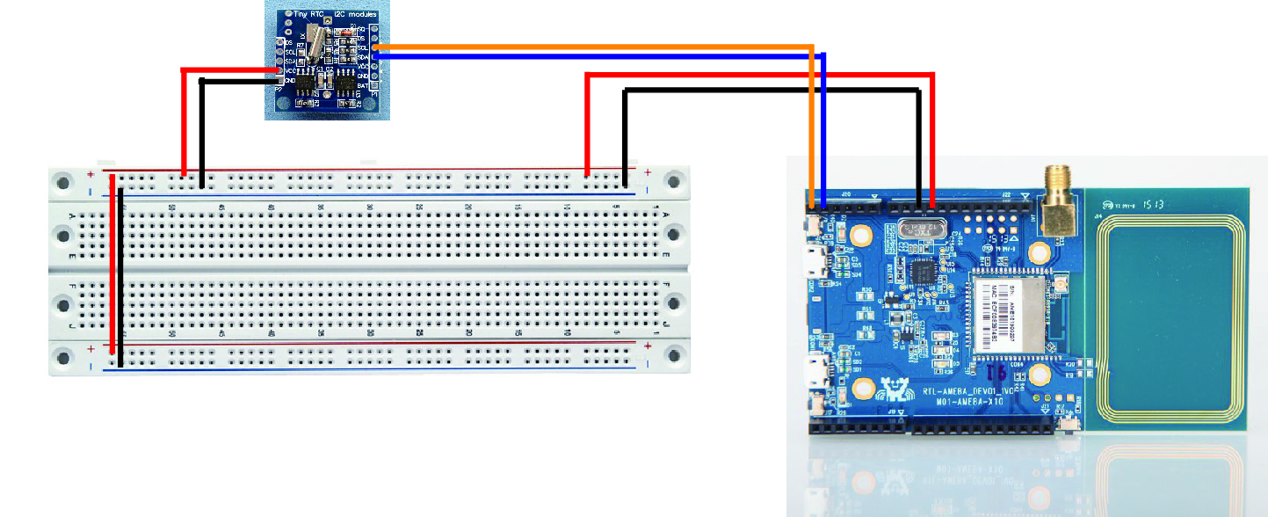

#include <Wire.h>
#include "RTClib.h"
RTC_DS1307 RTC;
// above is used for RTC
#include "PMType.h"
#include <WiFi.h>
#include <PubSubClient.h>
#include <WiFiUdp.h>
// Aboev is used for WIFI
uint8_t MacData[6];

char ssid[] = "TSAO_1F"; // your network SSID (name)
char pass[] = "TSAO1234"; // your network password
char server[] = "gpssensor.ddns.net"; // the MQTT server of LASS

#define MAX_CLIENT_ID_LEN 10
#define MAX_TOPIC_LEN 50
char clientId[MAX_CLIENT_ID_LEN];
char outTopic[MAX_TOPIC_LEN];

IPAddress Meip , Megateway , Mesubnet ;
String MacAddress ;
int status = WL_IDLE_STATUS;
WiFiUDP Udp;
const char ntpServer[] = "pool.ntp.org";
const long timeZoneOffset = 28800L;
const int NTP_PACKET_SIZE = 48; // NTP time stamp is in the first 48 bytes of the message
const byte nptSendPacket[ NTP_PACKET_SIZE] = {
0xE3, 0x00, 0x06, 0xEC, 0x00, 0x00, 0x00, 0x00, 0x00, 0x00, 0x00, 0x00, 0x31, 0x4E, 0x31, 0x34,
0x00, 0x00, 0x00, 0x00, 0x00, 0x00, 0x00, 0x00, 0x00, 0x00, 0x00, 0x00, 0x00, 0x00, 0x00, 0x00,
0x00, 0x00, 0x00, 0x00, 0x00, 0x00, 0x00, 0x00, 0x00, 0x00, 0x00, 0x00, 0x00, 0x00, 0x00, 0x00
};
byte ntpRecvBuffer[ NTP_PACKET_SIZE ];

#define LEAP_YEAR(Y) ( ((1970+Y)>0) && !((1970+Y)%4) && ( ((1970+Y)%100) || !((1970+Y)%400) ) )
static const uint8_t monthDays[] = {31, 28, 31, 30, 31, 30, 31, 31, 30, 31, 30, 31}; // API starts months from 1, this array starts from 0
uint32_t epochSystem = 0; // timestamp of system boot up
unsigned long epoch ;
int NDPyear, NDPmonth, NDPday, NDPhour, NDPminute, NDPsecond;
// this is used for WIFI and NTP

void setup() {
Serial.begin(9600);
initRTC() ;
// init RTC Modules
MacAddress = GetWifiMac() ;
ShowMac() ;
initializeWiFi();
ShowNTPDateTime() ;
SetRTCTime(NDPyear, NDPmonth, NDPday, NDPhour, NDPminute, NDPsecond);
delay(1500);
}

void loop() { // run over and over
delay(1000); // delay 1 minute for next measurement
Serial.print("Now RTC Data and Time is :") ;
Serial.print(ShowDateTime()) ;
Serial.print("\n") ;
delay(1000) ;

}

void ShowNTPDateTime()
{
retrieveNtpTime() ;
getCurrentTime(epoch + timeZoneOffset, &NDPyear, &NDPmonth, &NDPday, &NDPhour, &NDPminute, &NDPsecond);
//ttt->year = NDPyear ;
Serial.print("NDP Date is :");
Serial.print(StringDate(NDPyear, NDPmonth, NDPday));
Serial.print("and ");
Serial.print("NDP Time is :");
Serial.print(StringTime(NDPhour, NDPminute, NDPsecond));
Serial.print("\n");

}
void ShowMac()
{

Serial.print("MAC:");
Serial.print(MacAddress);
Serial.print("\n");

}

void ShowInternetStatus()
{

if (WiFi.status())
{
Meip = WiFi.localIP();
Serial.print("Get IP is:");
Serial.print(Meip);
Serial.print("\n");

}
else
{
Serial.print("DisConnected:");
Serial.print("\n");
}

}

void initRTC()
{
Wire.begin();
RTC.begin();
if (! RTC.isrunning()) {
Serial.println("RTC is NOT running!");

}
}
String ShowDateTime()
{

return StrDate() + " " + StrTime() ;
}

String StrDate() {
String ttt ;
//nowT = now;
DateTime now = RTC.now();
ttt = print4digits(now.year()) + "-" + print2digits(now.month()) + "-" + print2digits(now.day()) ;
//ttt = print4digits(NDPyear) + "/" + print2digits(NDPmonth) + "/" + print2digits(NDPday) ;
return ttt ;
}

String StringDate(int yyy, int mmm, int ddd) {
String ttt ;
//nowT = now;
ttt = print4digits(yyy) + "-" + print2digits(mmm) + "-" + print2digits(ddd) ;
return ttt ;
}

String StrTime() {
String ttt ;
// nowT = RTC.now();
DateTime now = RTC.now();
ttt = print2digits(now.hour()) + ":" + print2digits(now.minute()) + ":" + print2digits(now.second()) ;
// ttt = print2digits(NDPhour) + ":" + print2digits(NDPminute) + ":" + print2digits(NDPsecond) ;
return ttt ;
}

String StringTime(int hhh, int mmm, int sss) {
String ttt ;
ttt = print2digits(hhh) + ":" + print2digits(mmm) + ":" + print2digits(sss) ;
return ttt ;
}

String print2digits(int number) {
String ttt ;
if (number >= 0 && number < 10)
{
ttt = String("0") + String(number);
}
else
{
ttt = String(number);
}
return ttt ;
}

String print4digits(int number) {
String ttt ;
ttt = String(number);
return ttt ;
}

String GetWifiMac()
{
String tt ;
String t1, t2, t3, t4, t5, t6 ;
WiFi.status(); //this method must be used for get MAC
WiFi.macAddress(MacData);

Serial.print("Mac:");
Serial.print(MacData[0], HEX) ;
Serial.print("/");
Serial.print(MacData[1], HEX) ;
Serial.print("/");
Serial.print(MacData[2], HEX) ;
Serial.print("/");
Serial.print(MacData[3], HEX) ;
Serial.print("/");
Serial.print(MacData[4], HEX) ;
Serial.print("/");
Serial.print(MacData[5], HEX) ;
Serial.print("~");

t1 = print2HEX((int)MacData[0]);
t2 = print2HEX((int)MacData[1]);
t3 = print2HEX((int)MacData[2]);
t4 = print2HEX((int)MacData[3]);
t5 = print2HEX((int)MacData[4]);
t6 = print2HEX((int)MacData[5]);
tt = (t1 + t2 + t3 + t4 + t5 + t6) ;
Serial.print(tt);
Serial.print("\n");

return tt ;
}
String print2HEX(int number) {
String ttt ;
if (number >= 0 && number < 16)
{
ttt = String("0") + String(number, HEX);
}
else
{
ttt = String(number, HEX);
}
return ttt ;
}

// send an NTP request to the time server at the given address
void retrieveNtpTime() {
Serial.println("Send NTP packet");

Udp.beginPacket(ntpServer, 123); //NTP requests are to port 123
Udp.write(nptSendPacket, NTP_PACKET_SIZE);
Udp.endPacket();

if (Udp.parsePacket()) {
Serial.println("NTP packet received");
Udp.read(ntpRecvBuffer, NTP_PACKET_SIZE); // read the packet into the buffer

unsigned long highWord = word(ntpRecvBuffer[40], ntpRecvBuffer[41]);
unsigned long lowWord = word(ntpRecvBuffer[42], ntpRecvBuffer[43]);
unsigned long secsSince1900 = highWord << 16 | lowWord;
const unsigned long seventyYears = 2208988800UL;
// epoch = secsSince1900 - seventyYears + timeZoneOffset ;
epoch = secsSince1900 - seventyYears ;

epochSystem = epoch - millis() / 1000;
}
}

void SetRTCTime( int yr, int mon, int dd, int hr, int mins, int secs) {
RTC.adjust(DateTime(yr, mon, dd, hr, mins, secs));
}

void getCurrentTime(unsigned long epoch, int *year, int *month, int *day, int *hour, int *minute, int *second) {
int tempDay = 0;

*hour = (epoch % 86400L) / 3600;
*minute = (epoch % 3600) / 60;
*second = epoch % 60;

*year = 1970;
*month = 0;
*day = epoch / 86400;

for (*year = 1970; ; (*year)++) {
if (tempDay + (LEAP_YEAR(*year) ? 366 : 365) > *day) {
break;
} else {
tempDay += (LEAP_YEAR(*year) ? 366 : 365);
}
}
tempDay = *day - tempDay; // the days left in a year
for ((*month) = 0; (*month) < 12; (*month)++) {
if ((*month) == 1) {
if (LEAP_YEAR(*year)) {
if (tempDay - 29 < 0) {
break;
} else {
tempDay -= 29;
}
} else {
if (tempDay - 28 < 0) {
break;
} else {
tempDay -= 28;
}
}
} else {
if (tempDay - monthDays[(*month)] < 0) {
break;
} else {
tempDay -= monthDays[(*month)];
}
}
}
(*month)++;
*day = tempDay + 2; // one for base 1, one for current day
}

void initializeWiFi() {
while (status != WL_CONNECTED) {
Serial.print("Attempting to connect to SSID: ");
Serial.println(ssid);
// Connect to WPA/WPA2 network. Change this line if using open or WEP network:
status = WiFi.begin(ssid, pass);
//status = WiFi.begin(ssid);

// wait 10 seconds for connection:
delay(10000);
}
Serial.print("Success to connect AP:") ;
Serial.print(ssid) ;
Serial.print("\n") ;

// local port to listen for UDP packets
Udp.begin(2390);
}

void printWifiData()
{
// print your WiFi shield's IP address:
Meip = WiFi.localIP();
Serial.print("IP Address: ");
Serial.println(Meip);
Serial.print("\n");

// print your MAC address:
byte mac[6];
WiFi.macAddress(mac);
Serial.print("MAC address: ");
Serial.print(mac[5], HEX);
Serial.print(":");
Serial.print(mac[4], HEX);
Serial.print(":");
Serial.print(mac[3], HEX);
Serial.print(":");
Serial.print(mac[2], HEX);
Serial.print(":");
Serial.print(mac[1], HEX);
Serial.print(":");
Serial.println(mac[0], HEX);

// print your subnet mask:
Mesubnet = WiFi.subnetMask();
Serial.print("NetMask: ");
Serial.println(Mesubnet);

// print your gateway address:
Megateway = WiFi.gatewayIP();
Serial.print("Gateway: ");
Serial.println(Megateway);
}

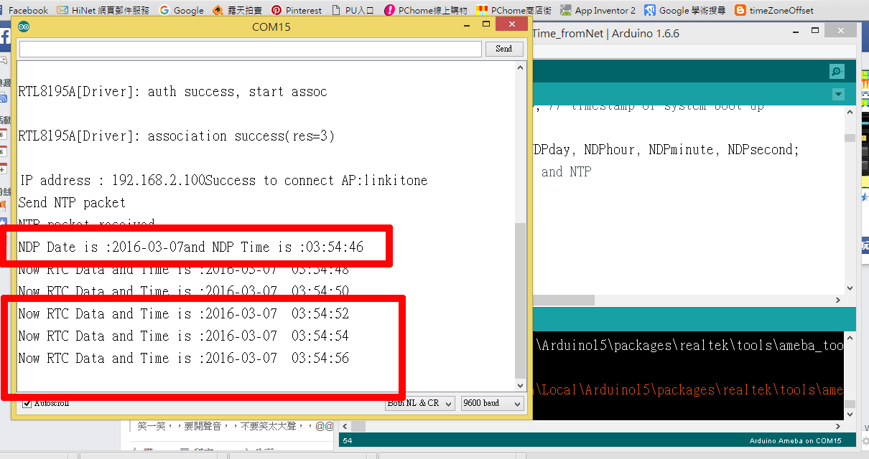

SetTime_fromNet 程式重點解說
- #include <WiFi.h> 使用網路必要函數
- uint8_t MacData[6]; 儲存 MAC資料
- initRTC() ; 初始化時鐘模組
- ShowNTPDateTime() ; 取得網路時間並顯示
- retrieveNtpTime() ;取得網路時間
- getCurrentTime(epoch+timeZoneOffset, &NDPyear, &NDPmonth, &NDPday, &NDPhour, &NDPminute, &NDPsecond); 將網路時間存入變數
- SetRTCTime(NDPyear, NDPmonth, NDPday, NDPhour, NDPminute, NDPsecond); 將取得網路時間調整時鐘模組

