程式：WebServerControlRelay 使用Client模式建立網頁伺服器
開啟程式WebServerControlRelay
程式位址：https://github.com/brucetsao/BruceCourses/blob/master/105ANQU_IOT/Code/WebServerControlRelay/WebServerControlRelay.ino
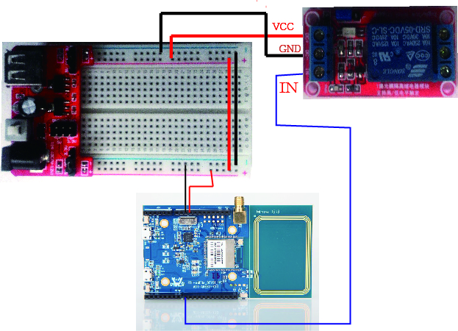
#include <WiFi.h>

char ssid[] = "Apple_TC_Wi-Fi"; // your network SSID (name)
char pass[] = "27541147"; // your network password
int keyIndex = 0; // your network key Index number (needed only for WEP)

int status = WL_IDLE_STATUS;
WiFiServer server(80);

#define RelayPin 8
#define Turnon HIGH
#define Turnoff LOW

void setup() {
Serial.begin(9600); // initialize serial communication
pinMode(RelayPin, OUTPUT); // set the LED pin mode
// check for the presence of the shield:
if (WiFi.status() == WL_NO_SHIELD) {
Serial.println("WiFi shield not present");
while (true); // don't continue
}

String fv = WiFi.firmwareVersion();
if (fv != "1.1.0") {
Serial.println("Please upgrade the firmware");
}

// attempt to connect to Wifi network:
while (status != WL_CONNECTED) {
Serial.print("Attempting to connect to Network named: ");
Serial.println(ssid); // print the network name (SSID);

// Connect to WPA/WPA2 network. Change this line if using open or WEP network:
// status = WiFi.begin(ssid); //no pass
status = WiFi.begin(ssid, pass); //wpa use
// wait 10 seconds for connection:
delay(10000);
}
server.begin(); // start the web server on port 80
printWifiStatus(); // you're connected now, so print out the status
}

void loop() {
WiFiClient client = server.available(); // listen for incoming clients

if (client) { // if you get a client,
Serial.println("new client"); // print a message out the serial port
String currentLine = ""; // make a String to hold incoming data from the client
while (client.connected()) { // loop while the client's connected
if (client.available()) { // if there's bytes to read from the client,
char c = client.read(); // read a byte, then
Serial.write(c); // print it out the serial monitor
if (c == '\n') { // if the byte is a newline character

// if the current line is blank, you got two newline characters in a row.
// that's the end of the client HTTP request, so send a response:
if (currentLine.length() == 0) {
// HTTP headers always start with a response code (e.g. HTTP/1.1 200 OK)
// and a content-type so the client knows what's coming, then a blank line:
client.println("HTTP/1.1 200 OK");

client.println("Content-type:text/html");
client.println();

// the content of the HTTP response follows the header:
client.print("Click <a href=\"/H\">here</a> turn Power on<br>");
client.print("Click <a href=\"/L\">here</a> turn Power off<br>");

// The HTTP response ends with another blank line:
client.println();
// break out of the while loop:
break;
} else { // if you got a newline, then clear currentLine:
currentLine = "";
}
} else if (c != '\r') { // if you got anything else but a carriage return character,
currentLine += c; // add it to the end of the currentLine
}

// Check to see if the client request was "GET /H" or "GET /L":
if (currentLine.endsWith("GET /H")) {
digitalWrite(RelayPin, Turnon); // GET /H turns the LED on
}
if (currentLine.endsWith("GET /L")) {
digitalWrite(RelayPin, Turnoff); // GET /L turns the LED off
}
}
}
// close the connection:
client.stop();
Serial.println("client disonnected");
}
}

void printWifiStatus() {
// print the SSID of the network you're attached to:
Serial.print("SSID: ");
Serial.println(WiFi.SSID());

// print your WiFi shield's IP address:
IPAddress ip = WiFi.localIP();
Serial.print("IP Address: ");
Serial.println(ip);

// print the received signal strength:
long rssi = WiFi.RSSI();
Serial.print("signal strength (RSSI):");
Serial.print(rssi);
Serial.println(" dBm");
// print where to go in a browser:
Serial.print("To see this page in action, open a browser to http://");
Serial.println(ip);
}

WebServerControlRelay程式重點解說
- #include <WiFi.h> 使用網路必要函數
- WiFiServer server(80); 啟動PORT 80進行
- status = WiFi.begin(ssid); 不使用加密連AP
- status = WiFi.begin(ssid, pass); 使用加密連AP
- server.begin(); 開始啟動PORT 80 傾聽
- printWifiStatus(); 列印網路資訊
- WiFiClient client = server.available(); 有人連接Port 80
- client.connected() 有用戶連接中
- client.available() 用戶送資料進來
- char c = client.read(); 讀出用戶送的資料(一個位元組)
- client.println(“HTTP/1.1 200 OK”); …. 送給用戶端一段HTML碼，用瀏覽器方能顯示
- currentLine.endsWith(“GET /H”) 判斷是否用/H 結束
- currentLine.endsWith(“GET /L”) 判斷是否用/L 結束
- client.stop(); 與用戶連線停止傳輸資料

