程式：APMODEControlRelay 使用AP模式建立網頁伺服器
開啟程式APMODEControlRelay
程式位址：https://github.com/brucetsao/BruceCourses/blob/master/105ANQU_IOT/Code/APMODEControlRelay/APMODEControlRelay.ino 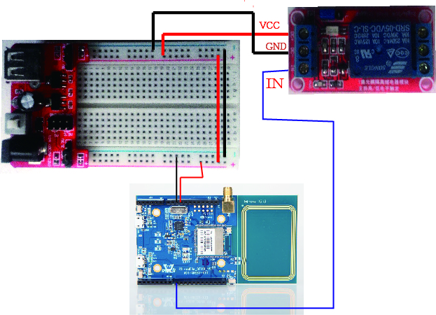
#include <WiFi.h>
#define RelayPin 8
#define Turnon HIGH
#define Turnoff LOW

char ssid[] = "Ameba"; //Set the AP's SSID
char pass[] = "12345678"; //Set the AP's password
char channel[] = "1"; //Set the AP's channel
int status = WL_IDLE_STATUS; // the Wifi radio's status

int keyIndex = 0; // your network key Index number (needed only for WEP)

WiFiServer server(80);

void setup() {
//Initialize serial and wait for port to open:
Serial.begin(9600);
pinMode(RelayPin, OUTPUT); // set the LED pin mode
// check for the presence of the shield:
if (WiFi.status() == WL_NO_SHIELD) {
Serial.println("WiFi shield not present");
while (true);
}
String fv = WiFi.firmwareVersion();
if (fv != "1.1.0") {
Serial.println("Please upgrade the firmware");
}

// attempt to start AP:
while (status != WL_CONNECTED) {
Serial.print("Attempting to start AP with SSID: ");
Serial.println(ssid);
status = WiFi.apbegin(ssid, pass, channel);
delay(10000);
}

//AP MODE already started:
Serial.println("AP mode already started");
Serial.println();
server.begin();
printWifiData();
printCurrentNet();
}

void loop() {
WiFiClient client = server.available(); // listen for incoming clients

if (client) { // if you get a client,
Serial.println("new client"); // print a message out the serial port
String currentLine = ""; // make a String to hold incoming data from the client
while (client.connected()) { // loop while the client's connected
if (client.available()) { // if there's bytes to read from the client,
char c = client.read(); // read a byte, then
Serial.write(c); // print it out the serial monitor
if (c == '\n') { // if the byte is a newline character

// if the current line is blank, you got two newline characters in a row.
// that's the end of the client HTTP request, so send a response:
if (currentLine.length() == 0) {
// HTTP headers always start with a response code (e.g. HTTP/1.1 200 OK)
// and a content-type so the client knows what's coming, then a blank line:
client.println("HTTP/1.1 200 OK");

client.println("Content-type:text/html");
client.println();

client.print("<title>Ameba AP Mode Control Relay</title>");
client.println();
client.print("<html>");
client.println();
// the content of the HTTP response follows the header:
client.print("Click <a href=\"/H\">here</a> turn Power on<br>");
client.print("Click <a href=\"/L\">here</a> turn Power off<br>");
client.println();
client.print("</html>");
client.println();

// The HTTP response ends with another blank line:
client.println();
// break out of the while loop:
break;
} else { // if you got a newline, then clear currentLine:
currentLine = "";
}
} else if (c != '\r') { // if you got anything else but a carriage return character,
currentLine += c; // add it to the end of the currentLine
}

// Check to see if the client request was "GET /H" or "GET /L":
if (currentLine.endsWith("GET /H")) {
digitalWrite(RelayPin, Turnon); // GET /H turns the LED on
}
if (currentLine.endsWith("GET /L")) {
digitalWrite(RelayPin, Turnoff); // GET /L turns the LED off
}
}
}
// close the connection:
client.stop();
Serial.println("client disonnected");
}
}

void printWifiData() {
// print your WiFi shield's IP address:
IPAddress ip = WiFi.localIP();
Serial.print("IP Address: ");
Serial.println(ip);

// print your subnet mask:
IPAddress subnet = WiFi.subnetMask();
Serial.print("NetMask: ");
Serial.println(subnet);

// print your gateway address:
IPAddress gateway = WiFi.gatewayIP();
Serial.print("Gateway: ");
Serial.println(gateway);
Serial.println();
}

void printCurrentNet() {
// print the SSID of the AP:
Serial.print("SSID: ");
Serial.println(WiFi.SSID());

// print the MAC address of AP:
byte bssid[6];
WiFi.BSSID(bssid);
Serial.print("BSSID: ");
Serial.print(bssid[0], HEX);
Serial.print(":");
Serial.print(bssid[1], HEX);
Serial.print(":");
Serial.print(bssid[2], HEX);
Serial.print(":");
Serial.print(bssid[3], HEX);
Serial.print(":");
Serial.print(bssid[4], HEX);
Serial.print(":");
Serial.println(bssid[5], HEX);

// print the encryption type:
byte encryption = WiFi.encryptionType();
Serial.print("Encryption Type:");
Serial.println(encryption, HEX);
Serial.println();
}

APMODEControlRelay程式重點解說
- #include <WiFi.h> 使用網路必要函數
- WiFiServer server(80); 啟動PORT 80進行
- status = WiFi.begin(ssid); 不使用加密連AP
- status = WiFi.begin(ssid, pass); 使用加密連AP
- server.begin(); 開始啟動PORT 80 傾聽
- printWifiStatus(); 列印網路資訊
- WiFiClient client = server.available(); 有人連接Port 80
- client.connected() 有用戶連接中
- client.available() 用戶送資料進來
- char c = client.read(); 讀出用戶送的資料(一個位元組)
- client.println(“HTTP/1.1 200 OK”); …. 送給用戶端一段HTML碼，用瀏覽器方能顯示
- currentLine.endsWith(“GET /H”) 判斷是否用/H 結束
- currentLine.endsWith(“GET /L”) 判斷是否用/L 結束
- client.stop(); 與用戶連線停止傳輸資料

