程式：Ameba Blink程式

開啟程式Blink
程式位址：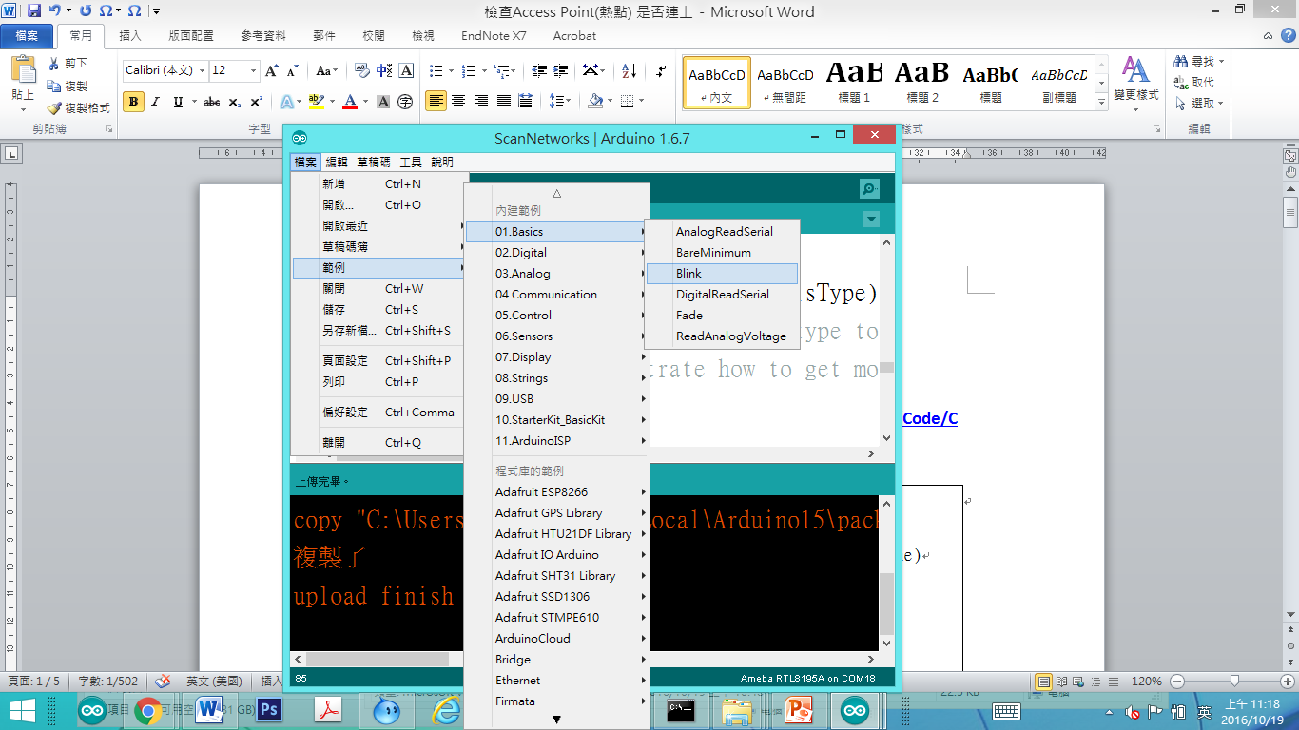
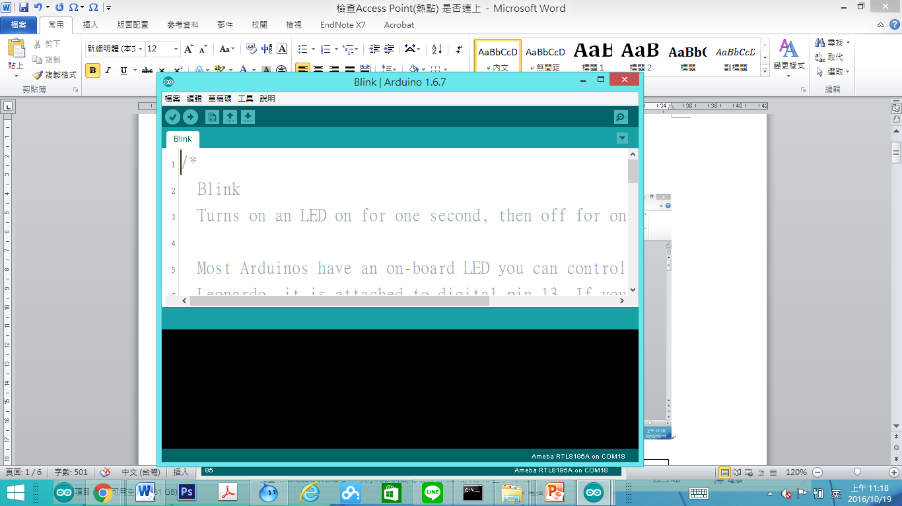

/*
Blink
Turns on an LED on for one second, then off for one second, repeatedly.

Most Arduinos have an on-board LED you can control. On the Uno and
Leonardo, it is attached to digital pin 13. If you're unsure what
pin the on-board LED is connected to on your Arduino model, check
the documentation at http://www.arduino.cc

This example code is in the public domain.

modified 8 May 2014
by Scott Fitzgerald
*/

// the setup function runs once when you press reset or power the board
void setup() {
// initialize digital pin 13 as an output.
pinMode(13, OUTPUT);
}

// the loop function runs over and over again forever
void loop() {
digitalWrite(13, HIGH); // turn the LED on (HIGH is the voltage level)
delay(1000); // wait for a second
digitalWrite(13, LOW); // turn the LED off by making the voltage LOW
delay(1000); // wait for a second
}

簡單來說，Blink 這個讓 LED 燈泡閃爍，它使用的GPIO接腳是13
Ameba的Pin一樣在D13的位置，根據Ameba的接腳位置圖：

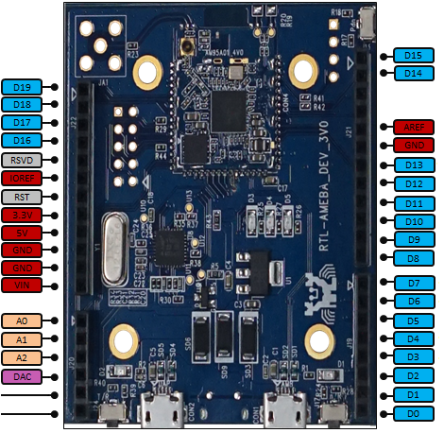

於是我們將電阻以及LED燈泡連接如下圖：
（NOTE：LED裡，長腳的是正極，接到D13的地方，短腳的是負極，接到GND的地方）

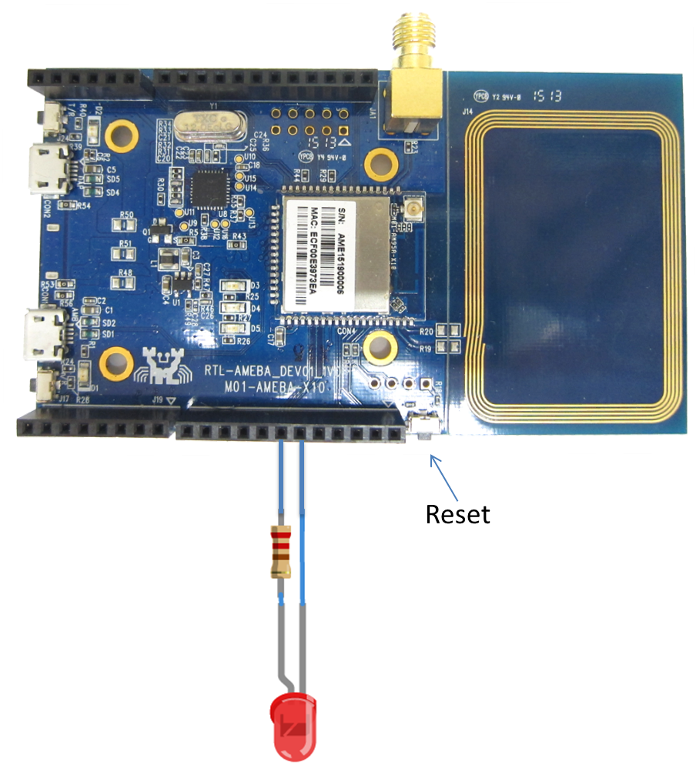

然後按一下Reset按鈕，就可以看到燈炮在閃爍，這個實驗就完成了。
如果以上過程遇到問題，請參考 Trouble-shooting 看是否能解決。

=========================================
CheckAP程式重點解說
pinMode(13, OUTPUT);’
digitalWrite(13, HIGH);
digitalWrite(13, LOW);

